|  |  |  |
| --- | --- | --- |
| **S.NO** | **PARTICLUARS** | **P.NO** |
| **1.** | **ABSTRACT** |  |
| **2.** | **INTRODUCTION** |  |
| **3.** | **SYSTEM ANALYSIS** |  |
| **4.** | **SYSTEM SPECIFICATION** |  |
| **5.** | **SYSTEM DESCRIPTION** |  |
| **6.** | **SYSTEM ENVIRONMENT** |  |
| **7.** | **SYSTEM DESIGN** |  |
| **8.** | **SYSTEM TESTING** |  |
| **9.** | **SOURCE CODE** |  |
| **10.** | **SCREEN LAYOUT** |  |
| **11.** | **CONCLUSION** |  |
| **12.** | **FUTURE ENCHANCEMENT** |  |
| **13.** | **BIBLOGRPHY** |  |

**ABSTRACT**

**ABSTRACT**

This project is entitled as “IOT Smart Gesture Watch” has been developed under PHP as front end along with Embedded C in kit and SQL SERVER as back end

This project aims at designing and executing the advanced development in become too busy, and is unable to find time even to switch the lights wherever not necessary. The present system is like, the smart gesture watch it is difficult for most of the people who are not familiar with this sign language to communicate without an interpreter .Thus, a system that transcribes symbols in sign languages into plain text can help with real-time communication .Talking gloves is an human interface device which converts concurrence with assistive to help dumb people of society and improve communication capabilities

**INTRODUCTION**

**INTRODUCTION**

Assistive technology, it is umbrella term which includes rehabilitative and adaptive devices for people with disabilities and also includes the process used in locating and using them. It promotes independence by enabling differentially able persons to perform various methods for interacting with the innovative technology needed to accomplish such tasks. It points to any piece of equipment, or product system, which is acquired commercialization, modification, or customization and this is used to maintain ,or improve functional capabilities of differentially able individuals.

Sign language is language which is use body movements to convey the meaning , as opposed to acoustically conveyed sound patterns. It is used by deaf and dumb to express their emotions before others non-verbal communication delivering some message is known as a gesture.

Talking Gloves is an example of assistive technology that converts sign language into words. A simple glove with accelerometers fitted in for each of the finger, is used for into arduino gives PVM signals. These signals are transmitted and received circuit gesture is recognized and signal (text information) is identified. That text information is converting the speech signal with the help of LM-386 and the words are played with the help of speaker.

**SYSTEM ANALYSIS**

**SYSTEM ANALYSIS**

**EXISTING SYSTEM**:

A fairly standard complaint amongst smart watch owners across the board, the Sony SW2 smart watch experiences some problematic battery issues that plague users of the device. Since the device uses Bluetooth connectivity in lot of it’s application and features, the constant connection taps into the battery of the device and causes it to lose juice far faster than the three days Sony claims the device remain powered. The same Bluetooth connection is used to push notification from your phone to your smart watch, and therefore, a phone that is constantly receiving notification about text messages can drain quickly and cause users headaches when utilizing the devices.

Smart watch implementing action on the screen often resulted in lag when switching between different apps and tools on the device. Furthermore, notification pushed from your cell phone to your smart watch can also both be slow to process as well as difficult to read due to the lag inherent with the smart watch.

**DISADVANTAGES**

Hardware cost might be the biggest worry for the user of the stand alone smart watch with all the bells of something like on LG watch phone prize 800. The prize is more than a high end and unlocked smart phone cost today just for the hardware.

Battery life to be a biggest challenge than any other hardware as the android wear is connected to your phone and mostly likely Bluetooth battery drain would be a major issue. Even in regular use, smart phones batteries might not even lost of hours. Pair it with on android wear and say goodbye to that as well.

**PROPOSED SYSTEM**:

The proposed system has using the aggregate session collection technique has used to find the Health care application from the mobile store download the user’s correct app. It will increase the reliability of the mobile apps and it have four important stages are used to find health care apps from the mobile store.

These four methods have to collect the information from the user according to mobile application .This collected thing has used to easily identify the apps correctly. This method has reduced the server storage of the health care mobile application. The project selected to hand six action and audio message convey for help man.

**ADVANTAGES**:

* It delivers notification straight to your wrist, and allows for the wearer to not have to check their phone so often you can get quick access to many function that would otherwise require a connection to a smart phone. This avoids digging into a pocket or purse for the smart watch or by hearing a tone on the smart phone of on voice notification. Studies show that users check a smart phone dozens of time a day, an quick glance at a watch would be more convenient.
* Options within the archive or delete the e-mail is so satisfactory.
* Speech recognition is one amongst the most effective option to date, that is healthier than human id smart phone.
* To correct misheard words “no I said” perform, terribly natural, however conjointly simple to use. Some most common words like this, and will be auto-corrected. Microsoft wants bring word prediction. But this is not actually word predication. It is auto-correction.
* Fast Google search perform is incredibly powerful and might facilitate users to quickly solve the matter.
* Smart watch could potentially help people with their health and fitness tracking ,this is already true of some of the smart watches being released, and we are sure to see more smart watches with fitness capabilities in the near future, especially because of the fact that many smart watches are including things like accelerometers.

**SYSTEM DESCRIPTION**

**SYSTEM DESCRIPTION MODULES**

* Sensor Interfacing
* Programming & Testing Hardware
* Linking Hardware and Android
* Android side view

**SENSOR INTERFACING**

In this module, we actually purchase and interface all the sensor with core micro controller. The microcontroller used here is ARDUINO UNO which basically acts as a controller module. This module mainly interfaces i.e., it connects all the sensor and other modules such as the input and output sensors to the Arduino microcontroller.

**PROGRAMMING AND TESTING HARDWAR**

This module has two steps, programming and Testing.

In Programming Module, coding for the microcontroller is done in Arduino IDE software and compiled

In Testing module, the program developed in Arduino is tested in the Software as well as in the hardware which we developed.

**LINKING HARDWARE AND ANDROID**

In this module, the developed hardware kit with arduino and IOT module is linked with android module. The android storage stands for storing all the information sent by the hardware.

**ANDROID VIEW**

The android side view module is performed to show the acquired information with date and time when there is a signal which comes from the hardware module.

**SYSTEM SPECIFICATION**

**SYSTEM SPECIFICATION**

**HADWARE REQUIREMENTS**

* Processor : snapdragon 845
* Storage :6GB RAM+128GB ROM
* Screen : Optic AMOLED 6.41”Display

**SOFTWARE REQUIREMENTS**

* Operating System : ANDROID
* Coding Language : JAVA

**SYSTEM ENVIORNMENT**

**ENVIORNMENT**

Android is a mobile operating system based on a modified version of the Linux kernel and other open source software, designed primarily for touch screen mobile devices such as smart phone and tablets. Android is developed by a consortium of developers known as the open Handset Alliance, With the main contributor and commercial marketer being.

Initially developed by Android Inc., which Google bought in 2005,Android was unveiled in 2007,with the first commercial Android devices launched in September 2008.The current stable version is Android 10,released on September 3,2019.The core Android source code is known as Android Open Source Project(AOSP),which is primarily licensed under the Apache License. This has allowed variants of Android to be developed on range of other electronic ,such as game consoles, digital cameras, PCs and others, each with a specialized user interface. Some well known derivatives include android tv for televisions and wear OS for wearable’s, both developed by Google.

Android’s source code has been used as the basis of different ecosystems, most notably that of Google which is associated with a suite of proprietary software called Google mobile services that frequently comes pre-installed on said devices. This includes core apps such as Gmail, the digital distribution platform Google play. And associated Google play. Services development platform, and usually apps such as the Google chrome web browser. These apps are licensed by manufacturers of android devices certified under standards imposed Google. Other competing android ecosystems include amazon.com fire OS, or lineages. Software distribution is generally offered through proprietary application stores like Google play store or Samsung galaxy store which use software packages I the APK format.

Android has been the best selling OS worldwide on smart phones since 2011and on tablets since 2013. As of may 2017, it has over two billion monthly active users, the largest installed base of any operating system, and as of January 2020, the Google play store features over 2.9 million apps.

**ANDROID ARICHITECTURE**

The android is a operating system and is a stack of software components which is divided into five sections and four main layers that is

* Linux kernel
* Libraries
* Android runtime

**LINUX KERNEL**

The on top of a Linux kennel there is a set of libraries including open source web browser such as Web kit, library lib. These libraries are used to play and record audio and video. The SQL is a data base which is useful for storage and sharing of application data. The SSL libraries are sharing of application data. The SSL libraries are responsible for internet security etc.

**ANDROID RUNTIME**

The android runtime provides a key component called Dalvik Virtual Machine which is a kind of java virtual machine .It is specially designed and optimized for android enables every android application to run it own process. The Dalvik VM executes the files in the .DEX format.

**APPLICATION FRAME WORK**

The application frame work layer provides many higher level services to applications such as windows manager, view system, package manger, resource manager etc. The application developers are allowed to make use of these services in their application.

**APPLICATION AND FEATURES:**

You will find all the android application at the top layer and you will write your application and install on this layer example of such application are contacts, book, browsers, services etc. Each application perform a different role in the overall application

**FEATURES:**

* Head set layout
* Storage
* Connectivity: GSM/EDGE, IDEN, CDMA, Bluetooth, WI-FI

EDGE,3G,NFC,LTE,GPS.

* Message:SMA,MMS,C2DM,GCM
* Multilanguage support
* Multi touch
* Video calling
* Screen capture
* External storage
* Streaming media support

**ANDROID EMULATOR**

The Emulator is a new application in android operating system. The emulator is a new prototype that is used to develop and test android application with put using any physical device. The android emulator has all of the hardware and software features like mobile device except phone calls. It provides a variety of navigation and control keys. It also provides a screen to display your application the utilize the android virtual device configurations. Once your application is running on it, it can use services of the android platform to help other applications, access the network, play audio video store and retrieve the data.

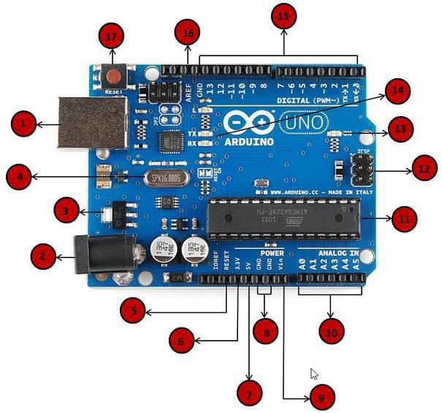

**APPLICATION OF ANDROID-ANDROID APPLICATION CONTROLLED REMOTE ROBOT**

**OPREATION**

It controls the robotic vehicle using an android application. The bluetooth device is interfaced to control unit on the robot for sensing the signals transmitted by the android application the remote operation is achieved by any smear-phone or table etc with android OS based on touch screen operation. The transmitting end uses an android application device remote through which commands are transmitted and the receiver side, these commands are used for controlling the robot in all direction such as forward, backward and left or right etc.

The receiver end movement is achieved by two motors that are interfaced to the microcontroller the serial communication data sent from the receiver that is interfaced to the microcontroller.

**ADVANTAGES**

* Android is Linux based open source operating system, it can be developed by any one
* Easy access to the android apps
* You can replace the battery and mass storage, disk drive and UDB option
* Its supports Multitasking
* Android phone can also function as a router to share internet
* Its free to customize
* Can install a modified ROM
* Its supports 2D and 3D graphics

**ARDUINO**

Arduino is a movement, not a microcontroller or not a chip(IC), not only a board (PCB), not a company or manufacture, not only a programming language or not only a computer architecture. Arduino is an open source hardware platform and also an open source development environment which is very easy to learn libraries and language (Arduino is based on a wiring language). Arduino has integrated development environment which is based on processing programming environment. Arduino is available for maximum operating systems means Arduino is available for windows, Linux, Mac etc.

Arduino is a tool which is used for making computer which can control or sense more of the physical world than our computer. Based on a simple microcontroller board, it is an open source physical computing platform. For writing software for board, there is development environment.

It is an open source electronics prototyping platform which is based on easy to use, flexible hardware and software. Arduino is intended for designers, artists, hobbyists, and anyone interested in creating an interactive environment or objects. Arduino is a microcontroller on a circuit board which makes it easy to receive inputs and drives the outputs. A microcontroller is an integrated computer on a chip.

1. **Power USB** Arduino board can be powered by using the USB cable from yourcomputer. All you need to do is connect the USB cable to the USB connection
2. **Power (Barrel Jack)** Arduino boards can be powered directly from the AC mains power supply by connecting it to the Barrel Jack.
3. **Voltage Regulator** The function of the voltage regulator is to control the voltage given to the Arduino board and stabilize the DC voltages used by the processor and other elements.

**(iv) Crystal Oscillator** The crystal oscillator helps Arduino in dealing with time issues. How does Arduino calculate time? The answer is, by using the crystal oscillator. The number printed on top of the Arduino crystal is 16.000H9H. It tells us that the frequency is 16,000,000 Hertz or 16 MHz.

**(v, xvii) Arduino Reset** You can reset your Arduino board, i.e., start your program from the beginning. You can reset the UNO board in two ways. First, by using the reset button (17) on the board. Second, you can connect an external reset button to the Arduino pin labelled RESET (5).

**(vi, vii, viii, ix) Pins (3.3, 5, GND, Vin)**

**3.3V (6) − Supply 3.3 output volt**

**5V (7) − Supply 5 output volt**

Most of the components used with Arduino board works fine with 3.3 volt and 5 volt.

**GND (8)(Ground) − There are several GND pins on the Arduino, any of which** can be used to ground your circuit.

**Vin (9) − This pin also can be used to power the Arduino board from an external** power source, like AC mains power supply.

1. **Analog pins** The Arduino UNO board has five analog input pins A0 through A5.These pins can read the signal from an analog sensor like the humidity sensor or temperature sensor and convert it into a digital value that can be read by the microprocessor.
2. **Main microcontroller** Each Arduino board has its own microcontroller (11). Youcan assume it as the brain of your board. The main IC (integrated circuit) on the Arduino is slightly different from board to board. The microcontrollers are usually of the ATMEL Company. You must know what IC your board has before loading up a new program from the Arduino IDE.
3. **ICSP pin** Mostly, ICSP (12) is an AVR, a tiny programming header for the Arduinoconsisting of MOSI, MISO, SCK, RESET, VCC, and GND. It is often referred to as an SPI (Serial Peripheral Interface), which could be considered as an "expansion" of the output. Actually, you are slaving the output device to the master of the SPI bus.
4. **Power LED indicator** This LED should light up when you plug your Arduino intoa power source to indicate that your board is powered up correctly. If this light does not turn on, then there is something wrong with the connection.
5. **TX and RX LEDs** On your board, you will find two labels: TX (transmit) and RX(receive). They appear in two places on the Arduino UNO board. First, at the digital pins 0 and 1, to indicate the pins responsible for serial communication. Second, the TX and RX led (13). The TX led flashes with different speed while sending the serial data. The speed of flashing depends on the baud rate used by the board. RX flashes during the receiving process.
6. **Digital I/O** The Arduino UNO board has 14 digital I/O pins (15) (of which 6provide PWM (Pulse Width Modulation) output. These pins can be configured to work as input digital pins to read logic values (0 or 1) or as digital output pins to drive different modules like LEDs, relays, etc. The pins labelled can be used to generate PWM.
7. **AREF** AREF stands for Analog Reference. It is sometimes, used to set an externalreference voltage (between 0 and 5 Volts) as the upper limit for the analog input pins.

* Microcontroller- ATmega2560
* Operating Voltage -5V
* Input Voltage (recommended)- 7-12V
* Input Voltage (limit)- 6-20V
* Digital I/O Pins 54 (of which 15 provide PWM output)
* Analog Input 16

**APPLICATIONS OF ARDUINO**

Arduino was basically designes to make the process of using electronics in multidisciplinary projects more accessible. It is inteded for artists,designers, hobbyists, and anyone interested in creating interactive objects or environments. Arduino can sense the environment by receiving input from a variety of sensors and can affect its surroundings by controlling lights, motors, and other actuators. because of these features, arduino finds extensive application in various fields.Arduino projects can be stand-alone or they can communicate with software running on a computer.

Arduino received an Honarary Mention in Digital Communication section of the 2006 Ars Electronica Prix

Arduino is used by all class of people in a different way.some students use it in their projects,some using arduino for fun,some went out to become entreupreuners. This only shows how useful is this tiny device.

Thousands of projects have been done worldwide using this tiny little device. some of which to mention are:

* Simple room temperature readout
* Interactive real-time auditory feedback system
* GPS receiver Module
* Ultrasonic Sensor
* Infrared detectors
* SONAR
* Various sensor projects like

Keypad security code

Sensor tube for heart monitor

Pulse rate monitor

* Various light projects like

Multicolor light display

Seven-segment LED display

Double seven-segment LED dice

LED array

LCD module

* Various sound projects like

Oscilloscope

Light harp

VU meter

* Various power projects like

LCD Thermostat

Computer controlled fan

The hypnotizer

* Miscellaneous Projects like

Lie detector

**BLUETOOTH MODULE HC-05**

We are using HC-05 Bluetooth module for our project which is simple to use for Bluetooth Serial Port Protocol (SPP) module and for the transparent wireless serial connection setup, we are designed a Bluetooth HC-05 module. With Serial Port Profile, HC-05 Bluetooth module is a class-2 module, which is configure as either slave or master. For wired serial connection, there is possibility of a drop-in replacement. To establish the connection, we can use HC-05 as a serial port replacement, between MCU, PC to our embedded project. Bluetooth module HC-05 will be simplified our overall design. HC-05 module has the footprint which is too small (12.7mm*27mm). With CMOS technology and Adaptive Frequency Hopping Feature (AFH), HC-05 module will be used CSR Bluecore04-External single chip Bluetooth system.

**FUTURE SCOPE**

Over the years, Arduino has went out to become a huge success and a common name among students. With google deploying it, people’s imagination has went out to much higher level than before. A developer in the annual GOOGLE IO conference said “when Arduino and Android coming together, this really proves “INFINITY EXISTS” in the future”. I think a study on arduino and practical experiments on arduino must be added for UG courses of engineering, to help students to leverage their talents, and imagination.

**GSM (Global System for Mobile Communication)**

GSM Modem can accept any GSM network operator SIM card and act just like a mobile phone with its own unique phone number. Advantage of using this modem will be that you can use its RS232 port to communicate and develop embedded applications. Applications like SMS Control, data transfer, remote control and logging can be developed easily using gsm. The modem can either be connected to PC serial port directly or to any microcontroller through MAX232. It can be used to send and receive SMS or make/receive voice calls.

It can also be used in GPRS mode to connect to internet and do many applications for data logging and control. In GPRS mode you can also connect to any remote FTP server and upload files for data logging. This GSM modem is a highly flexible plug and play quad band SIM900A GSM modem for direct and easy integration to RS232 applications. Supports features like Voice, SMS, Data/Fax, GPRS and integrated TCP/IP stack.

A GSM network comprises of many functional units. These functions and interfaces are explained in this chapter. The GSM network can be broadly divided into:

* + - The Mobile Station (MS)
    - The Base Station Subsystem (BSS)
    - The Network Switching Subsystem (NSS)
    - The Operation Support Subsystem (OSS)
* 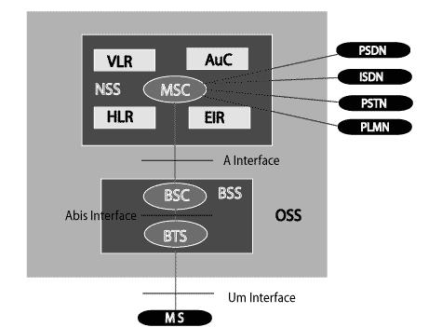Given below is a simple pictorial view of the GSM architecture.

FIG : GSM ARCHITECTURE

The additional components of the GSM architecture comprise of databases and messaging systems functions:

* + - Home Location Register (HLR)
    - Visitor Location Register (VLR)
    - Equipment Identity Register (EIR)
    - Authentication Centre (AuC)
    - SMS Serving Centre (SMS SC)

The following diagram shows the GSM network along with the added elements:

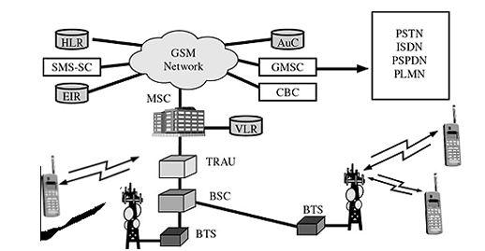**GSM Network architecture**

FIG : 3 GSM NETWORK ARCHITECTURE

The MS and the BSS communicate across the Um interface. It is also known as the *air* *interface* or the *radio link*. The BSS communicates with the Network Service Switching(NSS) centre across the *A* interface.

**GSM network areas**

In a GSM network, the following areas are defined:

* **Cell**: Cell is the basic service area; one BTS covers one cell. Each cell is given aCell Global Identity (CGI), a number that uniquely identifies the cell.

**PIR Sensor**

PIR sensors allow you to sense motion. They are used to detect whether a human has **moved in or out of the sensor’s range. They are commonly found** in appliances and gadgets used at home or for businesses. They are often referred to as PIR, "Passive Infrared", "Piezoelectric", or "IR motion" sensors.

**Following are the advantages of PIR Sensors**

* Small in size
* Wide lens range
* Easy to interface
* Inexpensive
* Low-power

PIRs are made of piezoelectric sensors, a round metal can with a rectangular crystal in the centre, which can detect levels of infrared radiation. Everything emits low-level radiation, and the hotter something is, the more radiation is emitted. The sensor in a motion detector is split in two halves.[4] This is to detect motion (change) and not average IR levels. The two halves are connected so that they cancel out each other. If one-half sees more or less IR radiation than the other, the output will swing high or low. PIRs have adjustable settings and have a header installed in the 3-pin ground/out/power pads.

Talking gloves is a human interface device which converts mechanism of hand sign language into alphanumerical characters. It is a product in concurrence with assistive engineering to help dumb people of society and improve communication capabilities. We are proposing a product in concurrence with assistive engineering to help the differentially- abled. This product targets the deaf and dumb. The objective of this project is to develop such a human interface device which converts the mechanism of American Sign Language into alphanumerical characters, then assist users to show and to communicate with others through voice. The goal of this project is to identify 4 numbers of American Sign Language, then play it through speaker or listen through ear cord

**Sign Language**

Nowadays, we can find a wide number of sign languages all over the world and almost every spoken language has its respective sign language. American Sign Language (ASL), Algerian Sign Language (ASL), Kenyan Sign Language (KSL), Mauritian Sign Language

(MSL), Irish Sign Language (IRSL), Tanzanian sign language, British Sign Language (BSL), Australian Sign Language (Auslan), German Sign Language (DGS), Indian Sign Language (ISL), and Spanish Sign Language (LSE), Yoruba Sign Language are just a few of them. Among all this large list, American Sign Language is cur-reentry the predominant of any sign language and its grammar has been successfully applied for various other sign languages such as British Sign Language. BSL is not closely related to ASL.

The goal is to provide the reader with a basic knowledge about the sign languages used by deaf and dumb people of the society. The following section will attempt to give a general description of the shared

Characteristics among the different sign languages: origin, phonology, and syntax (for the last two, contains an easy-to-understand description). By doing so, people who are not familiar with them will realize how complex it would be to design a whole Sign Language Translator and why the decision to simplify the system without taking into account these characteristics was made in the version of the system introduced here.

**Origin of sign language**

One of the earliest written records of a sign language is from the fifth century BC, in Plato's *Cratylus*, where Socrates says: "If we hadn't a voice or a tongue, and wanted to express things to one another, wouldn't we try to make signs by moving our hands, head, and the rest of our body, just as dumb people do at present?"

Until the 19th century, most of us know about historical sign that they are limited to the manual alphabets and they were invented to facilitate transfer of words from a spoken to a signed language. Sign language is mainly taught to deaf people, but its origin dates from the beginning history. In fact, gestures are the basic way that kids have to express their feelings until they learn their respective mother tongue.

The starting real study of sign languages is relatively younger compared to spoken languages. It dates from 1960, but today there is not an exact definition of their grammar. Since time immemorial, there is quantitative and qualitative advancement of sign language linguistics, but there are still few problems like the definition of a tool to transcript any sort of sign language.

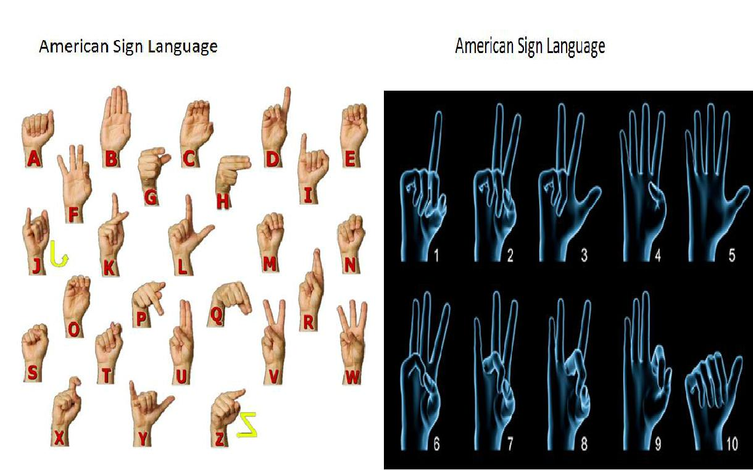

**PHONOLOGY**

In spoken language, the phonology denotes the study of physical sounds present in human speech (called phonemes). Similarly, the phonology of sign language can be defined. Instead of sounds, the phonemes are considered as the different signs present in a row of hand signs.

They are analyzed taking into account the following characteristics:

* Configuration: Hand shape while doing the sign.
* Orientation of the hand: Where the palm is pointing.
* Non-manual components: Refers to the information provided by the body (facial expression, movements of the shoulders or lip movements).

**System Architecture and Implementation**

In our project, we have five accelerometers fitted in each finger. The hand gesture for a

particular number provides the required data (i.e. acceleration measured by accelerometer).

This data is fed into Arduino Mega 2560. Here the data from all the five fingers is mappedinto the number represented by the particular hand gesture. This number is then send from

Bluetooth device hc-05 to internal Bluetooth i.e. hc-06.This internal Bluetooth acts as a relay to connect two external Bluetooth devices, the other one to receive the data.

**FLEX SENSOR**

These are based on carbon thick elements. When the thin substrate is bent, the sensor is produced a resistance output which is correlated to the bend radius. Smaller the radius, higher the resistance. These sensors require 5v input and output between 0-5V. The resistivity varies with sensor’s degree of bend and the voltage output changing accordingly.

Flex Sensors changes resistance in one direction only. An unflexed sensor has resistance of about 10Kohm. When the flex sensor is bent more, the resistance increases to 30-40Kohm at 90degree. One side of the sensor is printed with a polymer link that has conductive particles embedded in it. When sensor is straight, the particles give the link a resistance of say 30kohm. When sensor is bend away from link, the conductive particles move further apart increasing this resistance(to about 50Kohm).When the sensor straightens out again , the resistance returns to the original value. By measuring the resistance, we can determine how much sensor is bent.

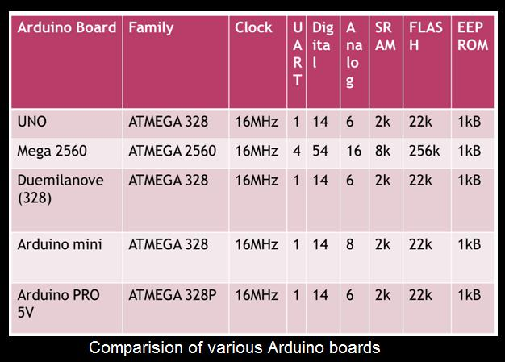

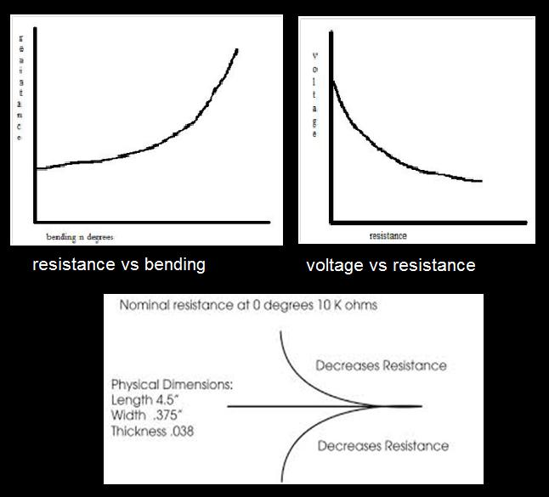

**ACCELEROMETER**

An accelerometer is a device that measures proper acceleration. Coordinate acceleration (rate of change) and proper acceleration are not same. Each of the accelerometers provide the x, y and z coordinates acceleration i.e. a change in gravitational force**.**

Accelerometer is an electromechanical device which is used to measure acceleration force. There are two types of Acceleration force for accelerometer, which are: static force, like the constant force of gravity pulling at our feet, and dynamic force – caused by moving or vibrating the accelerometer. Accelerometer is also used for measuring the tilt and motion. It means we also told that accelerometer is an electronic device which are used in measuring the tilt and motion. Accelerometer is capable for detecting rotation and motion gestures like a shaking or swinging.

**ARDUINO BOARD**

After getting analog signal from the flex sensor we need to convert this analog signal to digital signal by ADC. In our project we have used Arduino Mega 2560.Arduino is an open source physical computing platform that is based on a simple microcontroller board and a development environment for writing software. It can be used to develop interactive objects, taking inputs from a variety of lights, etc.

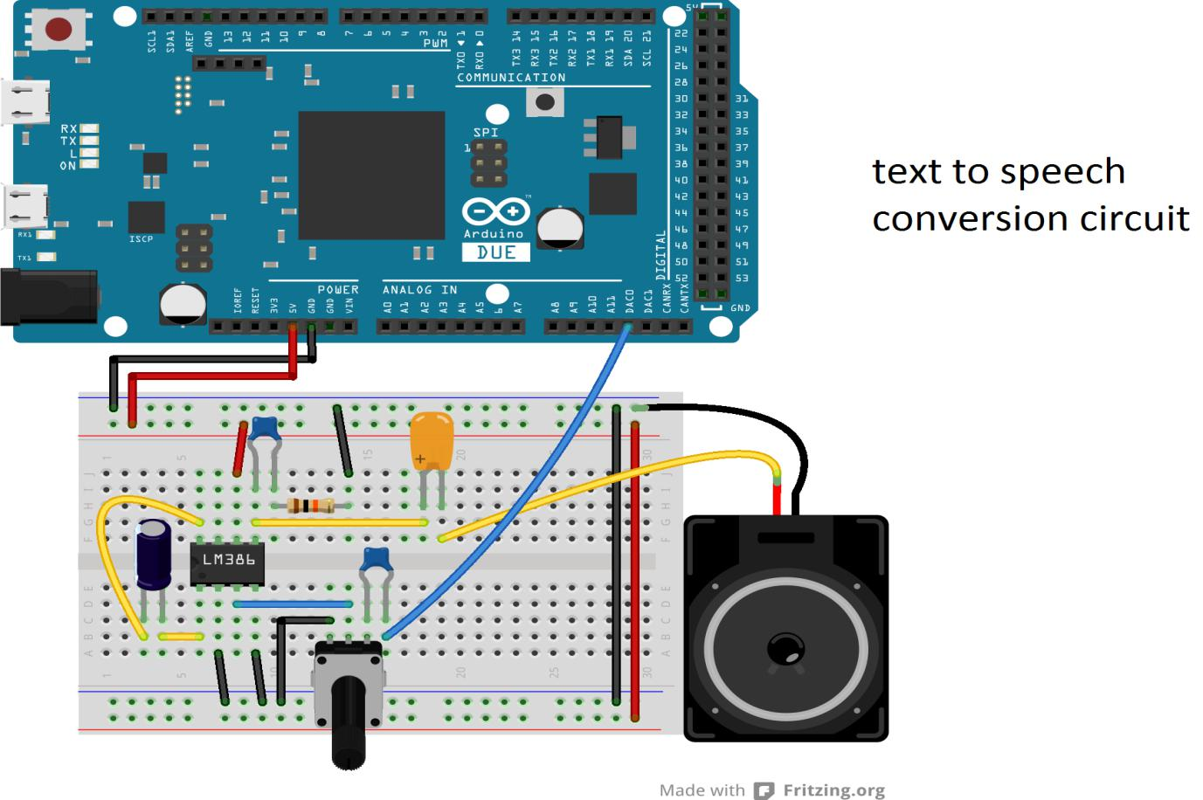

**BLUETOOTH MODULE**

We are using HC-05 Bluetooth module for our project which is simple to use for Bluetooth Serial Port Protocol (SPP) module and for the transparent wireless serial connection setup, we are designed a Bluetooth HC-05 module. With Serial Port Profile, HC-05 Bluetooth module is a class-2 module, which is configure as either slave or master. For wired serial connection, there is possibility of a drop-in replacement. To establish the connection, we can use HC-05 as a serial port replacement, between MCU, PC to our embedded project. Bluetooth module HC-05 will be simplified our overall design. HC-05 module has the footprint which is too small (12.7mm*27mm). With CMOS technology and Adaptive Frequency Hopping Feature (AFH), HC-05 module will be used CSR Bluecore04-External single chip Bluetooth system.

Specification:

There is two types of specification for Bluetooth module HC-05.

**HARDWARE SPECIFICATION**

|  |  |
| --- | --- |
| **Specifications** | **Range** |
|  |  |
| Sensitivity | 80dbm |
|  |  |
| RF Transmit Power | up to +4dbm |
|  |  |
| Operation power | 1.8V |
|  |  |
| Frequency range | 2.4GHz |
|  |  |
| .Emission power | 4dbm |
|  |  |
| Speed Range | 160kbps to 2.1 Mbps |
|  |  |
| Power supply | +3.3V, 50 mA |
|  |  |

**SOFTWARE SPECIFICATION**

|  |  |
| --- | --- |
| **Specifications** | **Range** |
|  |  |
| Default Baud Rate | 38400bps |
|  |  |
|  | 9600, 19200, 38400, 57600, 115200, |
| Supported baud rate | 230400, 460800bps |
|  |  |
| Data Bits | 8 |
|  |  |
| Stop Bit | 1 |
|  |  |
| Parity Bit | No |
|  |  |
| Default auto-pairing pincode | 0000 |
|  |  |

**SYSTEM DESIGN**

**SYSTEM DESIGN**

For communication purpose Bluetooth technology can also be used in the transmitter section. Bluetooth is a wireless networking standard that is aimed at remote control and sensor applications which is suitable for operation in harsh radio environments and in isolated locations. But, the main disadvantages of Bluetooth is short range, low complexity, and low data speed. Therefore, GSM is more advantages over Bluetooth for communication. Hence author use GS modem. A GSM modem is a specialized type wireless modem that works with a GSM wireless network.

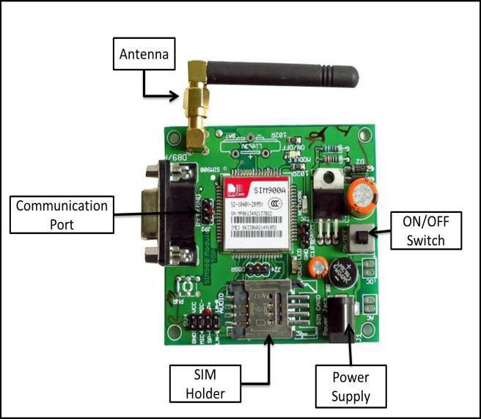 It accepts a SIM card, and operates over a subscription to a mobile operator, just like a mobile phone. A GSM modem can be an external device or a PC Card / PCMCIA Card. An external GSM modem is connected to a computer through a serial cable or a USB cable. When a GSM modem is connected to a computer, this allows the computer to communicate over the mobile network. While these GSM modems are most frequently used to provide mobile internet connectivity, many of them can also be used for sending and receiving SMS and MMS message. GSM Modem sends and receives data through radio waves. In this project GSM 900 modem is used to send the messages which is shown in figure 2.[2] It consists of a GSM/GPRS modem with standard communication interfaces like RS-232 (Serial Port), USB, so that it can be easily connected to the other devices. The power supply circuit is also built in the module that can be turn ON by using a suitable adaptor.

The block diagram of transmitter section. Level detector consists of IR sensors which is used to detect the level of the garbage in the dustbin. The output of level detector is given to microcontroller. Four IR sensors are used to indicate the different levels of the amount of the garbage collected in the dustbin which is placed in public area. When the dustbin is filled up to the highest level, the output of fourth IR receiver becomes active low. This output is given to microcontroller to send the message to the Control room via GSM module as shown in below.

Shows the block diagram of receiver section. At receiver, control room is present where all the activities are managing. The number of the control room is depending on the dustbins present in the area. The person sitting in the control room monitors the entire system. A GSM Module is connected to the computer of the control room through microcontroller. The entire system is monitor by the person sitting in the control room. The same GSM Module is used to send the message to the contractor for cleaning the dustbin. GUI is developed using MATLAB software. This GUI will be displayed on the computer screen in the control room to display the status of the garbage level in the dust bin as shown in below.

**Flow chat of Woking Principle**

Check

Whether

Health

Send Health

checking

Send message to mobile

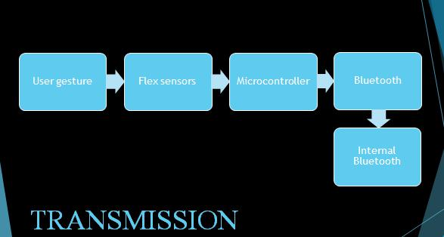

In our project, we have five accelerometers fitted in each finger. The hand gesture for a

particular number provides the required data (i.e. acceleration measured by accelerometer).

This data is fed into Arduino Mega 2560. Here the data from all the five fingers is mapped

into the number represented by the particular hand gesture. This number is then send from

Bluetooth device hc-05 to internal Bluetooth i.e. hc-06.This internal Bluetooth acts as a relay to connect two external Bluetooth devices, the other one to receive the data.

The received data is passed in to Arduino mega.In Receiver circuit we use Arduino for playing .wav file from Arduino. The .wav file played from SD Card module is amplified with the help of LM-386. Receiver circuit uses a speaker of 8 ohm. SD card inserted should be less than 2GB. Potentiometer and first order filtering circuit is being used for high amplitude and lowering noise respectively.

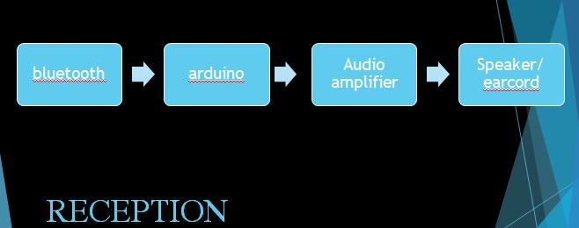

**SYSTEM TESTING**

**SYSTEM TESTING**

**TESTING**

A test case is an asset of data that the system will processor as a normal input. The strategies that we have used in our project are,

**SYSTEM TESTING**

Testing is the stage of implementation of which aimed at ensuring that the system works accurately and efficiently before live operations commence. Testing is vital to the success of the system. System testing makes a logical assumption that if all the parts of the system are correct the goal will be achieved. The candidates system subject to a variety of tests. Online response, volume, strees, recovery, security and usability tests. A series of testing are performed for the proposed system before the system is ready for user acceptance testing.

**UNIT TESTING**

The procedure level testing is made first. By giving improper inputs, the errors occurred are noted and eliminated. Then the web form level os made.

**INTEGRATION TESTING**

Testing is done for each module. After testing all the modules, the modules are integrated and testing of the final system is done with the test data, specially designed to show that the system will all its correct and an opportunity to show the user that the system works.

**VALIDATION TESTING**

The final step involves validating testing which determines whether the software function as the user expected. The end-user rather than the system developer conduct this test most software developers as a process called “Alpha and Beta test” to uncover that only the end user seems able to find. The compilation of the entire project is based on the full satisfaction of the end users.

**ACCPTANCE TESTING**

Acceptance testing can be defined in many ways, but a simple definition is the succeeds when the software function is manner that can be reasonable expected by the customer. After the acceptance test has been conducted. One of the two possible conditions exists. This is no fine whether the inputs are accepted by the database or other validations. For example accept only numbers in the numeric field, data format data in the data field. Also the null check for the not null fields. If any error occurs then show the error message. The function of performance characteristics to specification and is accepted. A deviation from specification is uncovered and a deficiency list is created.

**WHITE BOX TESTING**

White box testing, sometimes called “glass-box testing”, Using white box testing methods, the following tests were made on the system,

* All independent paths with in a module have been exercised at least once.
* All logical decision were checked for the true and false side of the values.
* All loops were executed to check their boundary values.
* Internal data-structure was tested for their validity.

**BLACK BOX TESTING**

Black box testing focuses on the functional requirements of the software. That is black box testing enables the software engineer to drive a set of input conditions that will fully exercise the requirements for a program. Black box testing is not an alternative for white box testing techniques. Rather, it is a complementary approach that is likely to uncover different class of errors. Black box testing attempts to find errors in the following categories:

Interface errors.

* Performance in data structure or external database access.
* Performance errors.
* Initialization and termination errors.
* Incorrect or missing functions.

**SOURCE CODE**

**SOURCE CODE**

**ARDUINO**

String inputString = ""; // a string to hold incoming data

boolean stringComplete = false;

const int senPin = 2;

const int buzPin = 3;

int buttonState = 0;

int s1,s2,s3,s4,s5;

void setup()

{

Serial.begin(9600);

pinMode(senPin, INPUT); // Sets the trigPin as an Output

pinMode(buzPin, OUTPUT);

digitalWrite(buzPin, HIGH);

Serial.println("AT"); // Echo back that character

delay(1000);

Serial.println("AT+CMGF=1"); // Echo back that character

delay(1000);

Serial.print("at+cstt=");

Serial.print('"');

Serial.print("airtelgprs.com");

Serial.println('"');

delay(1000);

Serial.println("at+cgatt=1");

delay(1000);

Serial.print("at+cgdcont=1,");

Serial.print('"');

Serial.print("IP");

Serial.print('"');

Serial.print(',');

Serial.print('"');

Serial.print("airtelgprs.com");

Serial.println('"');

delay(1000);

Serial.println("at+cgact=1,1");

delay(2000);

Serial.println("at+cgreg=2");

delay(2000);

Serial.println("AT+CIICR");

delay(1000);

Serial.println("AT+CIFSR");

delay(2000);

Serial.println("AT+CIPHEAD=1");

delay(2000);

Serial.print("AT+SAPBR=3,1,");

Serial.print('"');

Serial.print("Contype");

Serial.print('"');

Serial.print(',');

Serial.print('"');

Serial.print("GPRS");

Serial.println('"');

delay(2000);

Serial.print("AT+SAPBR=3,1,");

Serial.print('"');

Serial.print("APN");

Serial.print('"');

Serial.print(',');

Serial.print('"');

Serial.print("airtelgprs.com");

Serial.println('"');

delay(2000);

}

void loop()

{

s2= analogRead(A1);

// buttonState = digitalRead(senPin);

Serial.println(s2);

if (s2>20)

{

s2=1;

s3=1;

} else

{

s2=0;

s3=0;

}

s1= analogRead(A0);

if(s1<100)

{

s4=1;

}

else

{

s4=0;

}

Serial.println("AT+SAPBR=4,1");

delay(1000);

Serial.println("AT+SAPBR=1,1");

delay(2000);

Serial.println("AT+SAPBR=2,1");

delay(1000);

Serial.println("AT+HTTPINIT");

delay(2000);

Serial.print("AT+HTTPPARA=");

Serial.print('"');

Serial.print("URL");

Serial.print('"');

Serial.print(',');

Serial.print('"');

Serial.print("http://krprojects.000webhostapp.com/dustbin.php?");

Serial.print('A');

Serial.print('=');

//Serial.println("Load:");

Serial.print(s2);

Serial.print('&');

Serial.print('B');

Serial.print('=');

//Serial.println("Load:");

Serial.print(s1);

Serial.print('&');

Serial.print('C');

Serial.print('=');

//Serial.println("Load:");

Serial.print(s3);

Serial.print('&');

Serial.print('D');

Serial.print('=');

//Serial.println("Load:");

Serial.print(s4);

Serial.println('"');

delay(2000);

Serial.print("AT+HTTPPARA=");

Serial.print('"');

Serial.print("CID");

Serial.print('"');

Serial.print(',');

Serial.println('1');

delay(2000);

Serial.println("AT+HTTPACTION=0");

delay(5000);

Serial.println("AT+HTTPTERM");

delay(1000);

}

void serialEvent()

{

while (Serial.available())

{

char inChar = (char)Serial.read();

inputString += inChar;

if (inChar == '\n')

{

stringComplete = true;

Serial.println(inputString);

}

**PHP CODING**

<html>

<head>

<title>V3-Dustbin</title>

</head>

<body>

<font size="18" color="Blue"><center>Dustbin Monitoring System</center></font><br>

<font size="5" color="white"><center>Dustbin ID: 134 </center></font><br>

<font size="5" color="white"><center>Location: R.R.Nagar</center></font>

<br><div style="text-align: right;position: fixed;z-index:9999999;bottom: 0;width: auto;right: 1%;cursor: pointer;line-height: 0;display:block !important;"><a title="Hosted on free web hosting 000webhost.com. Host your own website for FREE." target="_blank" href="https://www.000webhost.com/?utm_source=000webhostapp&utm_campaign=000_logo&utm_medium=website&utm_content=footer_img">

<img src="https://cdn.000webhost.com/000webhost/logo/footer-powered-by-000webhost-white2.png" alt="www.000webhost.com"></a></div><script>function getCookie(t){for(var e=t+"=",n=decodeURIComponent(document.cookie).split(";"),o=0;o<n.length;o++)

{for(var a=n[o];" "==a.charAt(0);)a=a.substring(1);if(0==a.indexOf(e))return a.substring(e.length,a.length)}return""}getCookie("hostinger")&&(document.cookie="hostinger=;expires=Thu, 01 Jan 1970 00:00:01 GMT;",location.reload());

var wordpressAdminBody=document.getElementsByClassName("wp-admin")[0],notification=document.getElementsByClassName("notice notice-success is-dismissible"),hostingerLogo=document.getElementsByClassName("hlogo"),mainContent=document.getElementsByClassName("notice_content")[0],wpSidebar=document.getElementById("adminmenuwrap"),wpTopBarRight=document.getElementById("wp-admin-bar-top-secondary");

if(null!=wordpressAdminBody&&notification.length>0&&null!=mainContent){var googleFont=document.createElement("link");googleFontHref=document.createAttribute("href"),googleFontRel=document.createAttribute("rel"),googleFontHref.value="https://fonts.googleapis.com/css?family=Roboto:300,400,600",googleFontRel.value="stylesheet",googleFont.setAttributeNode(googleFontHref),googleFont.setAttributeNode(googleFontRel);

var css="@media only screen and (max-width: 576px) {#main_content {max-width: 320px !important;} #main_content h1 {font-size: 30px !important;} #main_content h2 {font-size: 40px !important; margin: 20px 0 !important;} #main_content p {font-size: 14px !important;} #main_content .content-wrapper {text-align: center !important;}} @media only screen and (max-width: 781px)

{#main_content {margin: auto; justify-content: center; max-width: 445px;} .upgrade-btn-sidebar {display: none;} #wp-toolbar .top-bar-upgrade-btn {width: 52px; height: 46px !important; padding: 0 !important;} .top-bar-upgrade-btn__text {display: none;} dashicons-star-filled.top-bar-upgrade-btn__icon::before {font-size: 28px; margin-top: 10px; width: 28px; height: 28px;}} @media only screen and (max-width: 1325px)

{.web-hosting-90-off-image-wrapper {position: absolute; max-width: 95% !important;} .notice_content {justify-content: center;} .web-hosting-90-off-image {opacity: 0.3;}} @media only screen and (min-width: 769px) {.notice_content {justify-content: space-between;} #main_content

{margin-left: 5%; max-width: 445px;} .web-hosting-90-off-image-wrapper {position: absolute; right: 0; display: flex; padding: 0 5%}} @media only screen and (max-width: 960px) {.upgrade-btn-sidebar {border-radius: 0 !important; padding: 10px 0 !important; margin: 0 !important;} .upgrade-btn-sidebar__icon {display: block !important; margin: auto;} .upgrade-btn-sidebar__text {display: none;}} .

web-hosting-90-off-image {max-width: 90%; margin-top: 20px;} .content-wrapper {z-index: 5} .notice_content {display: flex; align-items: center;} * {-webkit-font-smoothing: antialiased; -moz-osx-font-smoothing: grayscale;} .upgrade_button_red_sale{box-shadow: 0 2px 12px -6px #cc292f; max-width: 350px; border: 0; border-radius: 3px; background-color: #6747c7 !important; padding: 15px 55px !important; margin-bottom: 48px; font-size: 14px; font-weight: 800; color: #ffffff;} .

upgrade_button_red_sale:hover{color: #ffffff !important; background: rgba(103,71,199, 0.9) !important;} .upgrade-btn-sidebar {text-align:center;background-color:#ff4546;max-width: 350px;border-radius: 3px;border: 0;padding: 12px; margin: 20px 10px;display: block; font-size: 12px;color: #ffffff;font-weight: 700;text-decoration: none;} .upgrade-btn-sidebar:hover, .upgrade-btn-sidebar:focus, .upgrade-btn-sidebar:active

{background-color: rgba(255,69,70, 0.9); color: #ffffff;} .upgrade-btn-sidebar__icon {display: none;} .top-bar-upgrade-btn {height: 100% !important; display: inline-block !important; padding: 0 10px !important; color: #ffffff; cursor: pointer;} .top-bar-upgrade-btn:hover, .top-bar-upgrade-btn:active, .top-bar-upgrade-btn:focus {background-color: #ff4546 !important; color: #ffffff !important;}

.top-bar-upgrade-btn__icon {margin-right: 6px;}",style=document.createElement("style"),sheet=window.document.styleSheets[0];style.styleSheet?style.styleSheet.cssText=css:style.appendChild(document.createTextNode(css)),document.getElementsByTagName("head")[0].appendChild(style),document.getElementsByTagName("head")[0].appendChild(googleFont);

varbutton=document.getElementsByClassName("upgrade_button_red")[0],link=button.parentElement;link.setAttribute("href","https://www.hostinger.com/hosting-starter-offer?utm_source=000webhost&utm_medium=panel&utm_campaign=000-wp"),link.innerHTML='<button class="upgrade_button_red_sale">Upgrade Now</button>',(notification=notification[0]).setAttribute("style","background-color: #f8f8f8; border-left-color: #6747c7 !important;"),notification.className="notice notice-error is-dismissible";

Var mainContentHolder=document.getElementById("main_content"); mainContentHolder.setAttribute("style","padding: 0;"),hostingerLogo[0].remove();var h1Tag=notification.getElementsByTagName("H1")[0];h1Tag.className="000-h1",h1Tag.innerHTML="Limited Time Offer",h1Tag.setAttribute("style","color: #32454c; margin-top: 48px; font-size: 48px; font-weight: 700;");

Var h2Tag=document.createElement("H2");h2Tag.innerHTML="From $0.79/month",h2Tag.setAttribute("style","color: #32454c; margin: 20px 0 45px 0; font-size: 48px; font-weight: 700;"),h1Tag.parentNode.insertBefore(h2Tag,h1Tag.nextSibling);

var paragraph=notification.getElementsByTagName("p")[0];paragraph.innerHTML="Don’t miss the opportunity to enjoy up to <strong>4x WordPress Speed, Free SSL and all premium features</strong> available for a fraction of the price!",paragraph.setAttribute("style",'font-family: "Roboto", sans-serif; font-size: 18px; font-weight: 300; color: #6f7c81; margin-bottom: 20px;');var list=notification.getElementsByTagName("UL")[0];list.remove();

var org_html=mainContent.innerHTML,new_html='<div class="content-wrapper">'+mainContent.innerHTML+'</div><div class="web-hosting-90-off-image-wrapper"><img class="web-hosting-90-off-image" src="https://cdn.000webhost.com/000webhost/promotions/wp-inject-default-img.png"></div>';mainContent.innerHTML=new_html;

var saleImage=mainContent.getElementsByClassName("web-hosting-90-off-image")[0];wpSidebar.insertAdjacentHTML("beforeend",'<a href="https://www.hostinger.com/hosting-starter-offer?utm_source=000webhost&amp;utm_medium=panel&amp;utm_campaign=000-wp-sidebar" target="_blank" class="upgrade-btn-sidebar"><span class="dashiconsdashicons-star-filled upgrade-btn-sidebar__icon"></span><span class="upgrade-btn-sidebar__text">Upgrade</span></a>'),

wpTopBarRight.insertAdjacentHTML("beforebegin",'<a class="top-bar-upgrade-btn" href="https://www.hostinger.com/hosting-starter-offer?utm_source=000webhost&amp;utm_medium=panel&amp;utm_campaign=000-wp-top-bar" target="_blank"><span class="ab-icon dashicons-before dashicons-star-filled top-bar-upgrade-btn__icon"></span><spanclass="top-bar-upgrade-btn__text">Go Premium</span></a>')}</script><script type="text/javascript" src="https://a.opmnstr.com/app/js/api.min.js" data-campaign="f6brbmuxflyqoriatchv" data-user="71036" async></script></body>

<!--

<p align="center">

<button style="height:40px; width:120px" id="makeAjaxRequest">ON</button>

&nbsp;&nbsp;&nbsp;

<button style="height:40px; width:120px" id="makeAjaxRequest1">OFF</button>

</p>

-->

</html>

<form id="mail_subscribe" align='center' method="POST" >

<input type="submit" name="r1" value="Clearlogs">

</form>

<br><br><table size='5' bgcolor='#FFFFFF' border='1' width='70%' align='center'>

<tr border='2' >

<th><font color='red'><center> ID </center></font></th>

<th><font color='red'><center> Level Sensor</center></font></th>

<th><font color='red'><center>GAS Sensor</center></font></th>

<th><font color='red'><center> Level Status</center></font></th>

<th><font color='red'><center> GAS Status</center></font></th>

<th><font color='red'><center> Next Check date</center></font></th>

<th><font color='red'><center> Time</center></font></th>

<th><font color='red'><center> Date</center></font></th>

<br>

<script>

(function()

{

var button = document.getElementById('makeAjaxRequest1');

button.addEventListener("click", function(){

loadXMLDoc();

});

functionloadXMLDoc() {

varxmlhttp = new XMLHttpRequest();

xmlhttp.onreadystatechange = function() {

if (xmlhttp.readyState == XMLHttpRequest.DONE) { // XMLHttpRequest.DONE == 4

if (xmlhttp.status == 200) {

console.log(xmlhttp.responseText);

//document.getElementById("myDiv").innerHTML = xmlhttp.responseText;

} else if (xmlhttp.status == 400) {

alert('There was an error 400');

} else {

alert('Send Successfully');

}

}

};

varjsonData = {

r1: 920

};

xmlhttp.open("POST","relay.php");

xmlhttp.setRequestHeader("Content-Type", "application/json;charset=UTF-8");

xmlhttp.send(JSON.stringify({ r1: 920}));

//xmlhttp.open("POST", "relay.php", true);

//var data = "r1=90";

//xmlhttp.send(jsonData);

}

})();

</script>

<script>

(function() {

var button = document.getElementById('makeAjaxRequest');

button.addEventListener("click", function(){

loadXMLDoc();

});

functionloadXMLDoc() {

varxmlhttp = new XMLHttpRequest();

xmlhttp.onreadystatechange = function() {

if (xmlhttp.readyState == XMLHttpRequest.DONE) { // XMLHttpRequest.DONE == 4

if (xmlhttp.status == 200) {

console.log(xmlhttp.responseText);

//document.getElementById("myDiv").innerHTML = xmlhttp.responseText;

} else if (xmlhttp.status == 400) {

alert('There was an error 400');

} else {

alert('something else other than 200 was returned');

}

}

};

varjsonData = {

r1: 90

};

xmlhttp.open("POST","relay.php");

xmlhttp.setRequestHeader("Content-Type", "application/json;charset=UTF-8");

xmlhttp.send(JSON.stringify({ r1: 90}));

//xmlhttp.open("POST", "relay.php", true);

//var data = "r1=90";

//xmlhttp.send(jsonData);

}

})();

</script>

<style>

body {

background-image: url('dust.jpg');

}

</style>

**CONCLUSION**

**CONCLUSION**

The project involves distinguishing among five different alphabets of English language. Future work may include recognition of all the English alphabets. Further, we may move on to recognizing words, from as large a dictionary as possible, from Indian Sign Language. Another method to improve the performance is by using android programming to use google to receive data and decode the received alphanumeric character

* Talking gloves was implemented for four numbers (0 , 1, 2 ,3 )
* The system was tested for ten different inputs per number.
* The .wav files were played corresponding to the respective numbers
* The sound is not audible properly due to SD card problem

**FUTURE ENCHANCEMENT**

**FUTURE SCOPE**

The project involves distinguishing among five different alphabets of English language. Future work may include recognition of all the English alphabets. Further, we may move on to recognizing words, from as large a dictionary as possible, from Indian Sign Language. Another method to improve the performance is by using android programming to use google to receive data and decode the received alphanumeric character.

**BIBLIOGRAPHY**

1. Auti, Abhijit; Puranik, V.G.; Kureshi, A.K. (2014) “Speaking Gloves for Speechless Persons.” International Journal of Innovative Research in Science, Engineering and

Technology. Vishwabharati Academy’s College of Engineering.

1. Havalagi, Praveenkumar S; Nivedita (2013). “The Amazing Digital Gloves That Give

Voice to the Voiceless.” International Journal of Advances in Engineering & Technology. ISSN: 2231-1963.

1. Khan, Yasir Niaz; Mehdi, Syed Atif (2009). “Sign Language Recognition using Sensor Gloves.” National University of Computer and Engineering Sciences, Lahore.
2. Karlan, G.R. (1990). “Manual Communication: Implications for Education.”

Gallaudet University Press, Washington, DC, USA. P 51 – 185.